### **Orion Model (Main Model):**

A fusion of Visual and IoT models, providing comprehensive functionalities for tracking, analysis, prediction, and response.

#### A. Visual Model:

* **Human Detection**:
* Technology: YOLOv7.
* Description: Detects and bounds humans within a scene.
* **Individual Tracking and Overcrowding Detection**:
* Technology: Kalman filter.
* Description: Tracks individuals across frames and detects overcrowding based on proximity or bounding box count.
* **Collision Prediction**:
* Technology: Kalman filter.
* Description: Predicts potential collisions between individuals based on future positions.
* **Activity Recognition** (Optional):
* Technology: Pose estimation, 3D-CNN, or LSTM.
* Description: Recognizes activities of individuals from visual data.

#### B. IoT Model:

* **Heart Rate Monitoring**:
* Technology: IoT sensors.
* Description: Monitors individuals' heart rates for safety and well-being.
* **Individual Tracking**:
* Technology: GPS data or pinging.
* Description: Tracks individual devices, storing the last location of lost devices.
* **Overcrowding Detection & Heatmap Generation**:
* Technology: Clustering and Kernel Density Estimation (KDE).
* Description: Detects overcrowding by clustering devices and generates heatmaps from GPS data.
* **Collision Prediction**:
* Technology: Predictive model using GPS data.
* Description: Checks whether two devices are on a collision course.
* **Activity Recognition** (Optional):
* Technology: IoT sensors like accelerometers, gyroscopes.
* Description: Recognizes activities from sensor data.
* **Contact Tracing**:
* Technology: Proximity data (GPS or pinging), graph-based model.
* Description: Marks devices in proximity and builds chains of contact for tracing.

#### Additional Components:

* **Alert System**:
* Description: Sends alerts for specific conditions like overcrowding or collisions.
* **Historical Analysis**:
* Technology: Database system.
* Description: Stores historical data for later analysis, including locations, alerts, predictions.
* **Emergency Evacuation Planning**:
* Technology: Graph-based algorithms, possibly Multi-Agent Reinforcement Learning (MARL).
* Description: Utilizes all data to plan optimal evacuation paths in emergencies.

**Diagram**

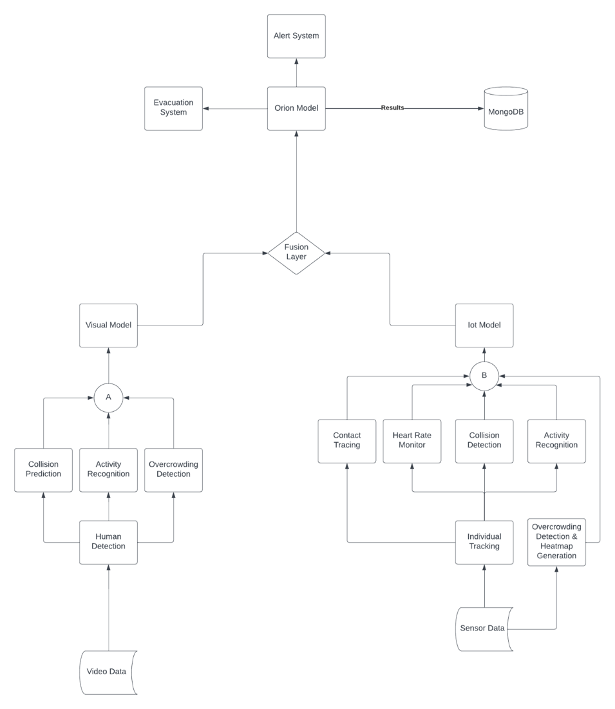

### **Summary:**

The Orion Model represents a comprehensive system that integrates visual and IoT data for a wide range of applications. It covers individual tracking, activity recognition, overcrowding detection, collision prediction, heart rate monitoring, heatmap generation, contact tracing, alerting, historical analysis, and emergency evacuation planning. By fusing these diverse functionalities, the system provides a robust and versatile solution for monitoring, analysis, and response in various contexts.